
North Campus
Assignment 2

Subject | DATABASE MANAGEMENT SYSTEMS | Program | BS(CS)
Faculty | Faraz Abdul Basit | Time Allowed
CLO, GA | CLO3  GA3  C4 – Analyze | Maximum Marks
A university maintains student academic and administrative data in the following unnormalized relation:
STUDENT_ENROLLMENT
(student_id, student_name, gender, contact, other_contact, course_codes, course_names, faculty_names, semester, semester_fee, fee_status, faculty_salary, faculty_contact)
A sample dataset is provided showing multiple courses per student, multiple faculty members, and repeating contact and salary information.

Tasks
a) Analyze the given dataset and identify all repeating groups, multivalued attributes, and partial dependencies present in the relation.
b) Identify all relevant functional dependencies based on the given attributes and sample data. Clearly state any assumptions made.
c) Analyze the anomalies (insertion, update, and deletion anomalies) that may arise if the relation is stored in its current unnormalized form.
d) Normalize the given relation step-by-step up to Third Normal Form (3NF). Clearly show:
- Decomposition at each normal form
- Resulting relations
- Primary keys and foreign keys
- e) Justify how your final normalized schema improves data consistency, eliminates redundancy, and supports future database scalability.
S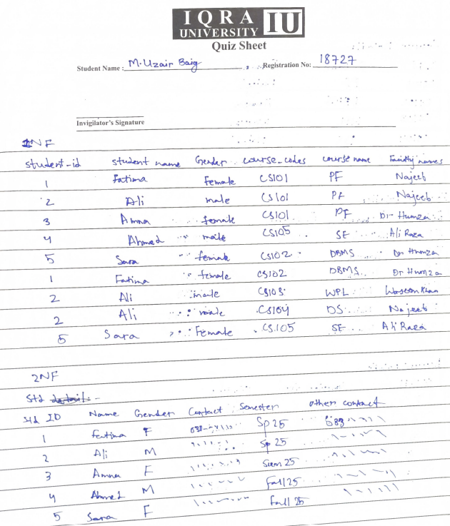
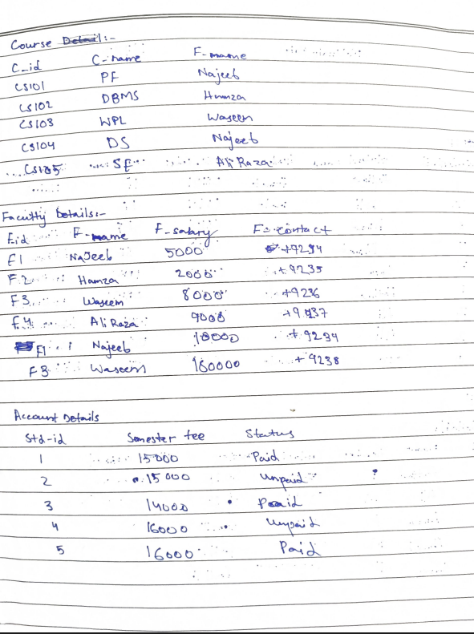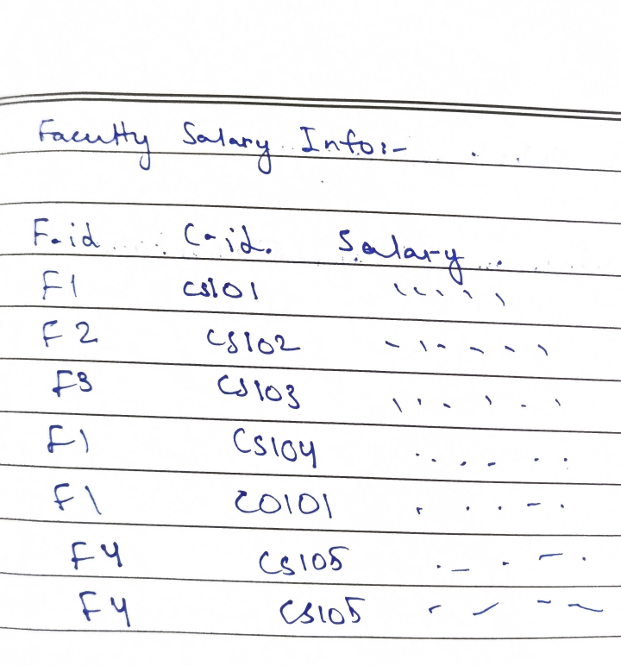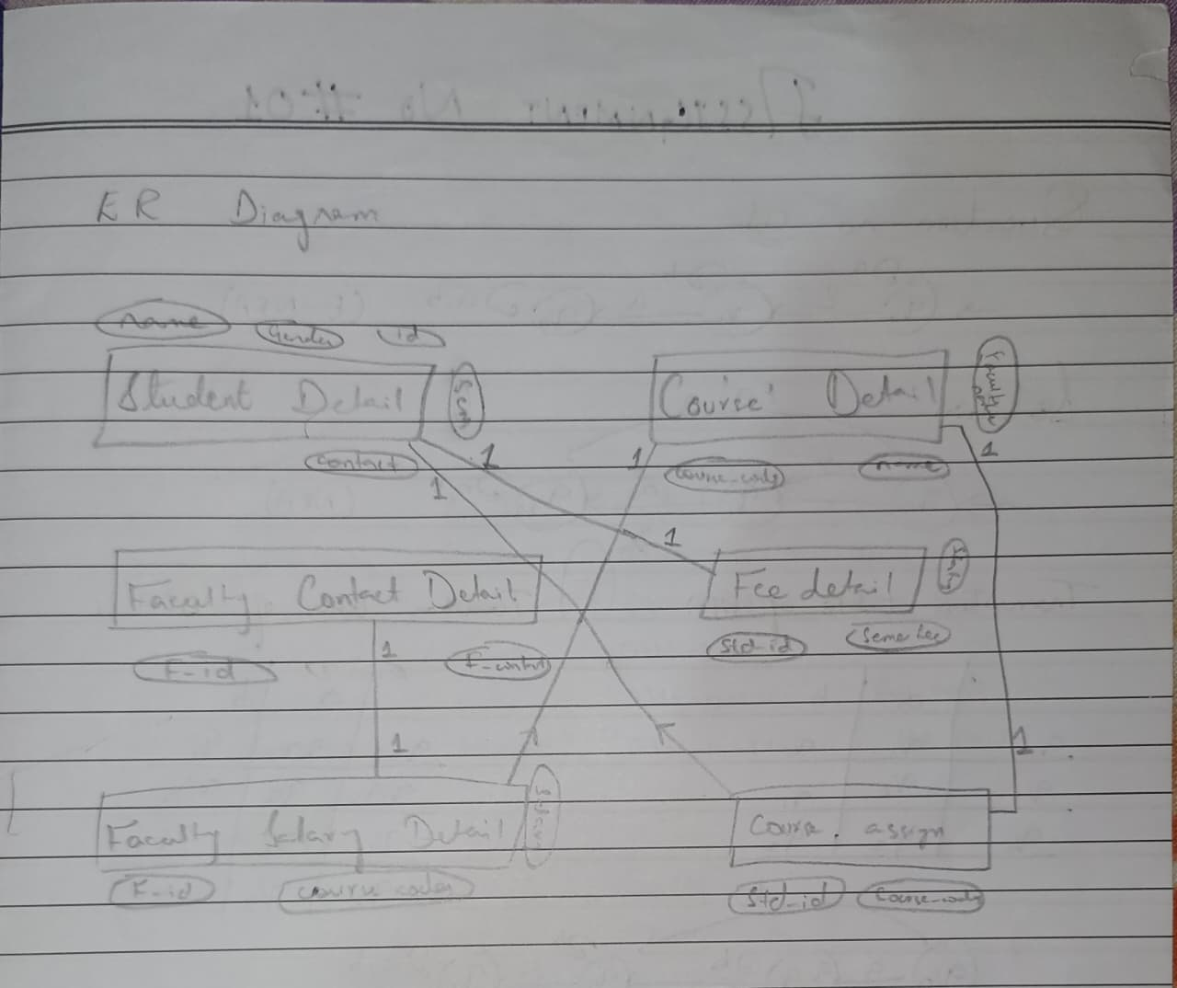
Conclusion:
The final normalized schema improves data consistency by ensuring that each piece of information is stored only once, reducing update and deletion anomalies. It eliminates redundancy by organizing data into well-structured related tables, which saves storage and avoids duplication. Moreover, the design supports future scalability by allowing new tables and attributes to be added easily without affecting existing data.

